 Air University Multan campus

Department of Computer Science and Engineening



<E-Library>

**Project Report**

Prepared by

|  |
| --- |
| Group # 01 |
| *<Ahsan-ul-Haq, 183227, Leader>* |
| *<Muhammad Huzaifa Rashid, 183203, Member>* |
| *<Mahum Sajjad, 183200, Member>* |
| *<Ansar Alam Khan, 183161, Member>* |
| *<Rosheen Amjad, 183162, Member>* |

**Introduction:**

The Project titled “E-Library” is a library management portal for monitoring and controlling the books stock and books issued to students.

**Context:**

Libraries thrive on proper organization, and this project is all about improving organization within the library. E-Library drive the improved management of every facet of the library, including books stock management, book issuing and members management.

**Problem:**

A E-Library system is an infrastructure that allows librarians to search books and, add/remove, and assign selected books. The problem faced is that librarians require an efficient method to monitor and control the books stock management, book issuing and members management.

**Response:**

Librarians manage the library and its assets, so they are the employees interacting with the library management application the most.

This type of systems typically contains user interfaces for library members. Library members can use the interface to check out library events and manage the assets they’ve borrowed from the library.

# **Project Goals and Objectives:**

The main goals and objectives of this project are to develop a system that should automate all the manual difficulties in managing the Library by implementing computerization.

The system should be capable of books stock management, book issuing, members management, search books and add/remove, and assign selected books.

# **The Solution:**

Proposed system is an automated Library Management System. Through our software user can add books, search books, renewal, update information, edit information, and return books in quick time. Our proposed system has the following advantages.

. User friendly interface

. Fast access to database

. Less error

. More Storage Capacity

. Search facility

. Look and Feel Environment

. Quick transaction

All the manual difficulties in managing the Library will be rectified by implementing computerization.

# **Project Scope:**

The E-Library is to be developed provides the Students of the University Library and staff with books information, online viewing of books and many other facilities. The Library Management System is supposed to have the following detailed features.

Scope of Initial Release: The early release of the new system will contain an online registration form for the students, an online E-Book portal and a backend database to process and store registration information and the Library System’s information, a secure internal network, and a Library’s administrators’ portal. This initial release will also include installation, configuration, and support documentation for the Librarian and the University Students and Staff. Since this initial release will be fully functional, it is essential to include user and technical support documentation to easily use and configure the E-portal so it is practically usable in the new Library environment.

# **Software Tools:**

## **6.1.Software**

The project “E-Library” will be developed in HTML, CSS, JavaScript using Django web framework.

# **Cost (if applicable)**

This project needs high quality Internet access and good performance PCs. So, the cost of the project include:

* Internet charges
* PCs cost
* Installation cost

**Working of Code Screen Shots:**

**Admin:**

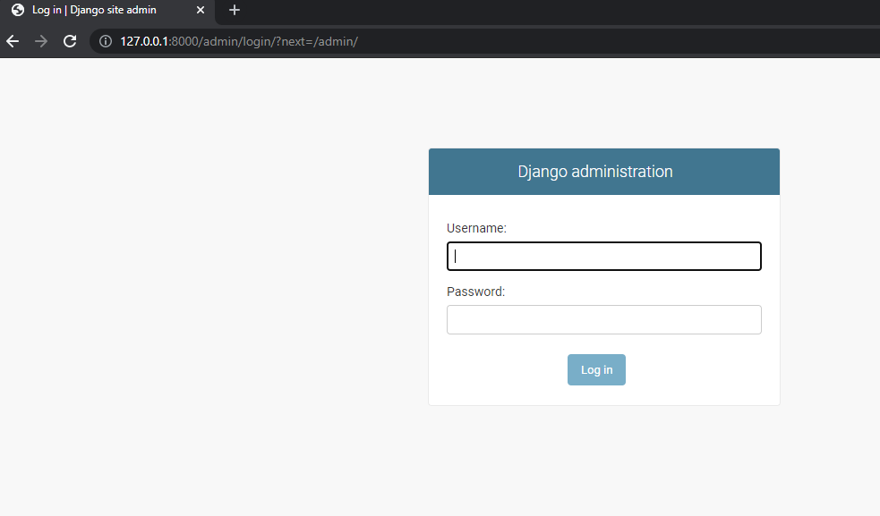

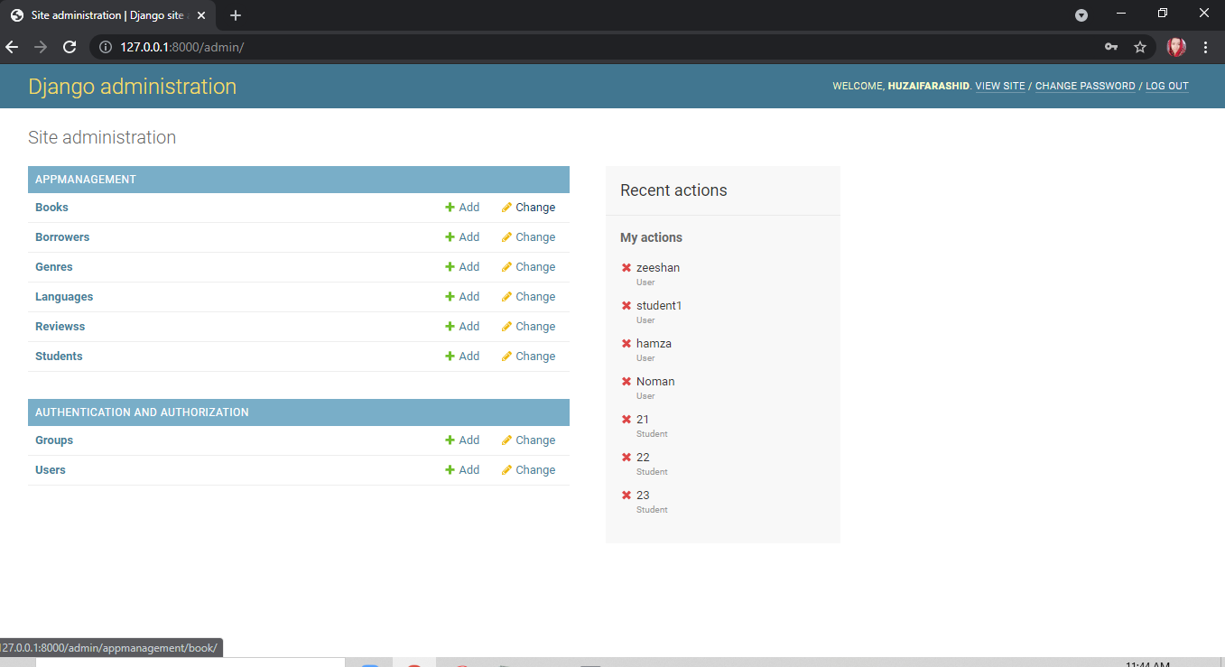

**E-Library System:**

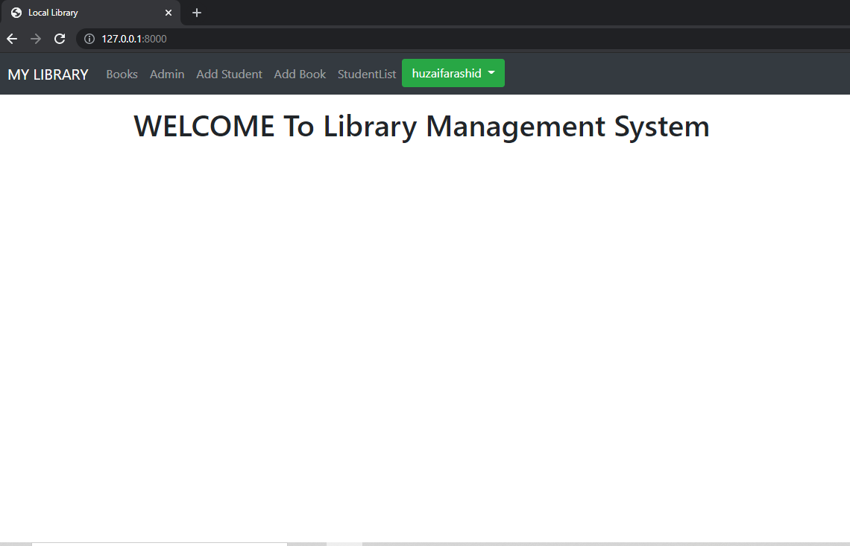

**Books:**

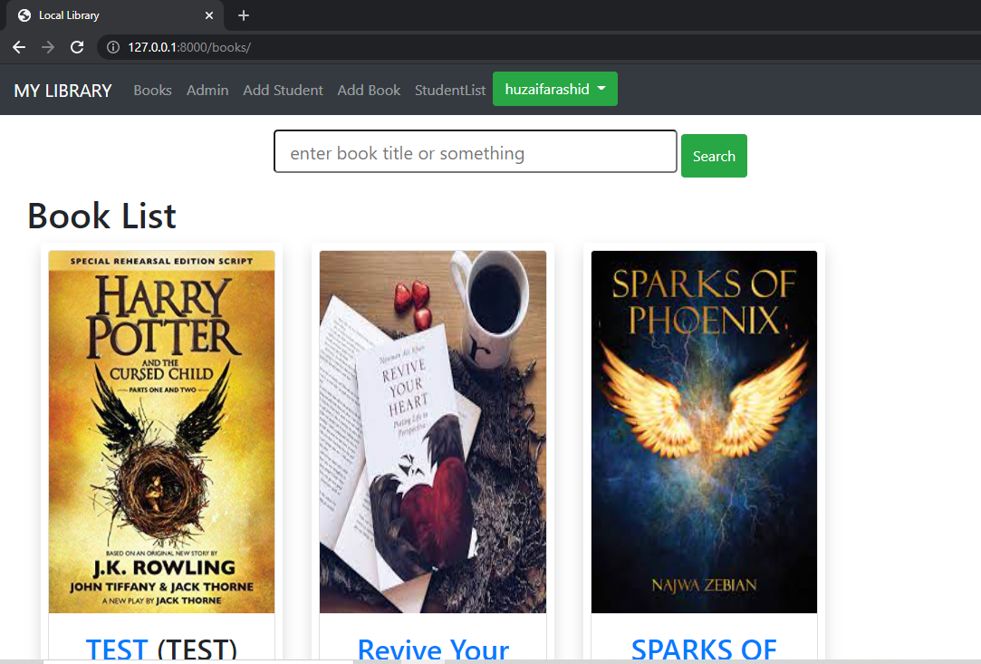

**Add Student:**

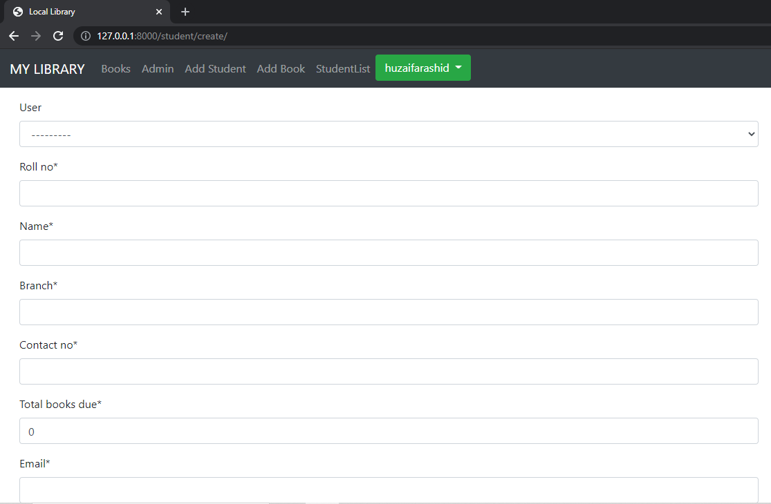

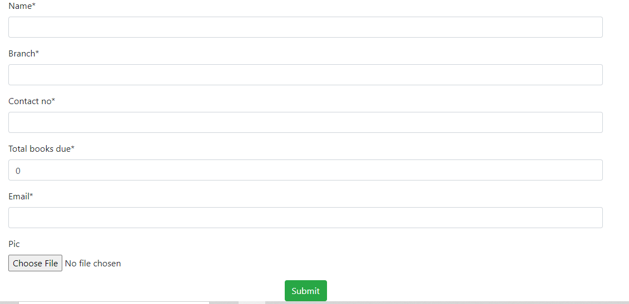

**Add Book:**

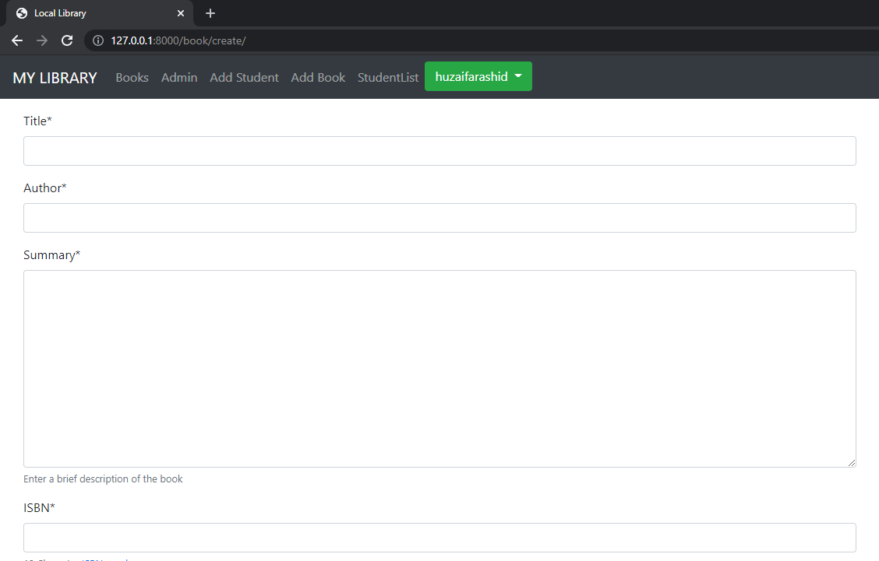

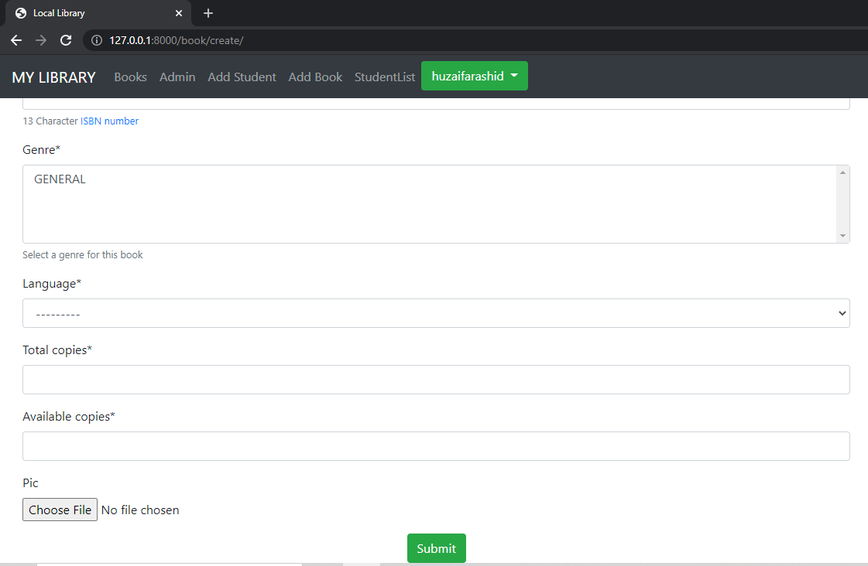

**Student List:**

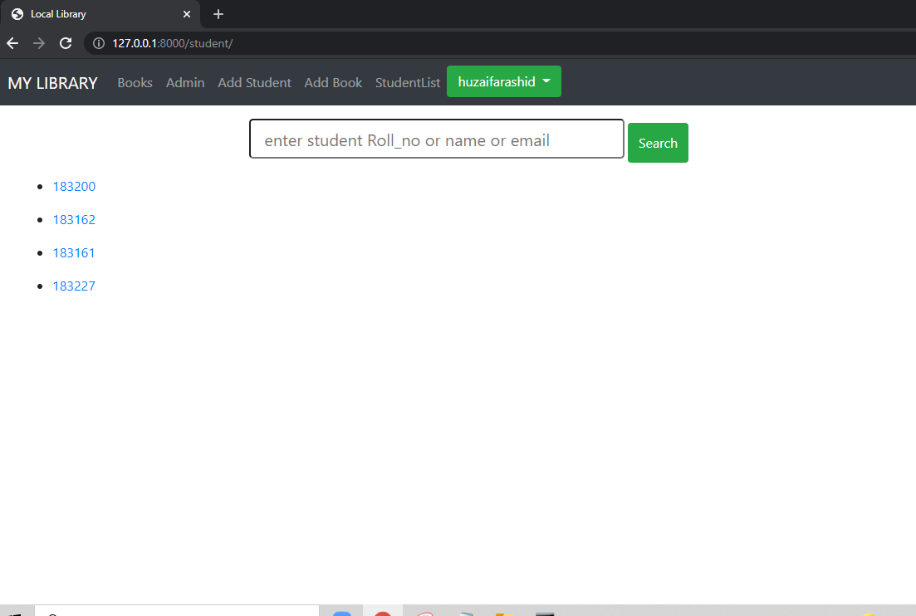

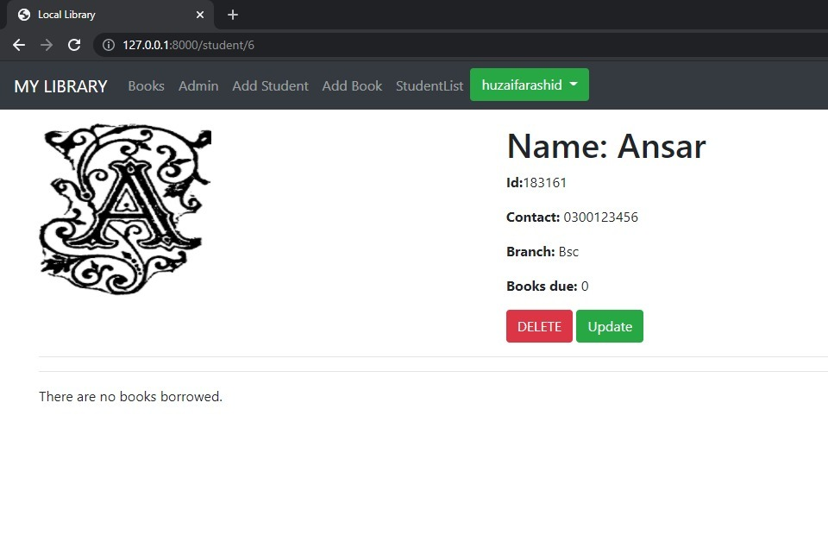

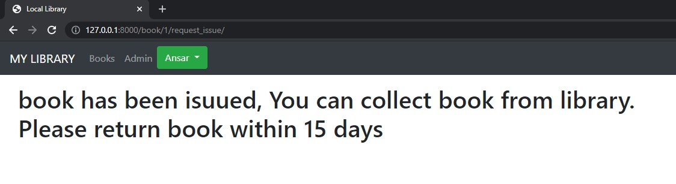

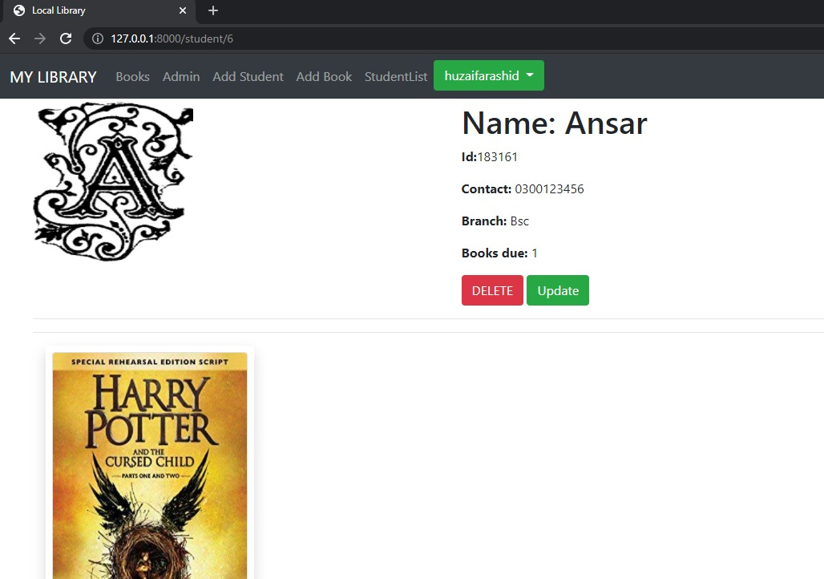

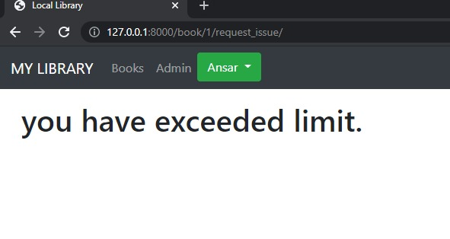

**Conclusion:**

Our main purpose of making this project is to make an E-Library that will convert all manual work and data of library into an automated Library management system that can be used by different libraries to automate there system.We tried our best to fullfill all the requirements that an automated system should have.